Overview - Introduction to Neural Networks

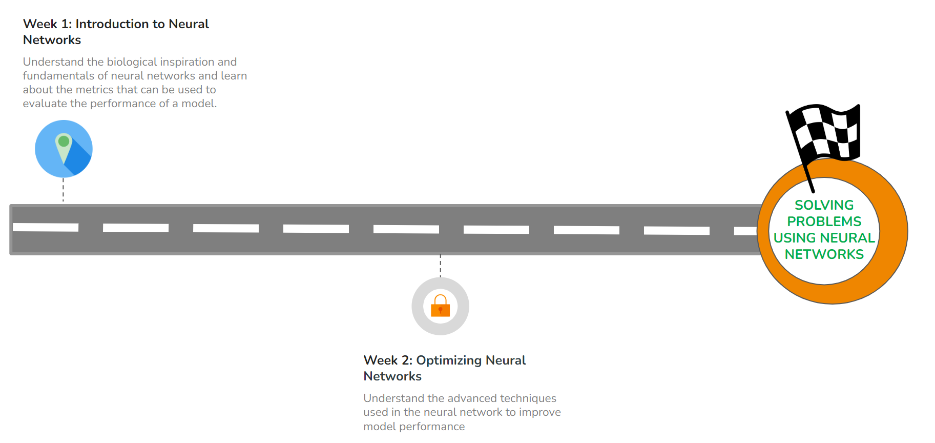

#### **WEEK 1 OVERVIEW**

This week, we will be learning about the foundations of a Neural Network. The following topics will be covered in this module:

* Deep Learning and History
* Multi-Layer Perceptron
* Types of Activation Functions
* Types of Loss Functions
* Training Neural Networks

#### **LEARNING INSTRUMENTS**

| **Week** | **Module** | **No. of videos** | **Total duration** | **No. of Test Your Understanding Quizzes** | **No. of Weekly Graded Quizzes** |
| --- | --- | --- | --- | --- | --- |
| 1 | Introduction to Deep Neural Networks | 16 | ~3 hours | 16 | 1 |

#### **Note: It is recommended to spend at least 1 hour/day along with practicing datasets and quizzes.**

**Power Ahead!**